Table of Contents

Hosting the Frontend in IIS for Private Access 2

Prerequisites 2

Setting-up Up the Site 2

Modifying Files to Run the Site without Internet Dependencies 3

How to Re-build CEMF Frontend 6

Hosting the Frontend in CEMF S3 Bucket 8

# Hosting the Frontend in IIS for Private Access

To host the application privately you need to deploy it to any web server. In this case we will busing IIS.

## Prerequisites

* Windows 2012 or later operating system
* Install basic IIS web server components. This is enough to host static content.
* Install IIS Manager
* The server where you host the page should be in the same region your CEMF S3 Bucket resides.



## Setting-up Up the Site

1. Create a folder where you will copy the build. In this case we created a folder under C:\Sites\CEMF folder.
2. Copy the all the content of your front-end S3 bucket or the build folder you created in How to Re-build CEMF Frontend. The structure should look like the one in the image.

**TIPS**: For S3 bucket you can use AWS Toolkit for you to download all the files at once. Bulk download is not supported by AWS console.

1. Open IIS Manager
2. Expand the tree and go to Application Pools.
   1. Click *Add Application Pool*.
   2. In the Application Pool window, enter the name of your application pool.
   3. Select the default .NET CLR version (.NET CLR Version v4.0.3XXX)
   4. Select *Integrated* in Managed pipeline mode
   5. Click Ok

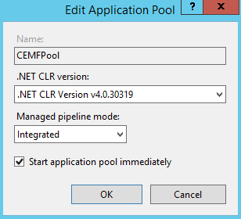

1. Click *Sites* node in the treeview, and click *Add Website*.
   1. In the add website window enter the *Site name*.
   2. Click the Select button to select the application pool we created in previous step.
   3. Physical path, enter the path of the folder you created in step #1.
   4. In IP address, select the private IP address.
   5. In Port, enter the port where you want to host the site
   6. You can leave the hostname blank unless you have DNS specified for the site.
   7. Check the Start Website immediately.
   8. Click Ok.

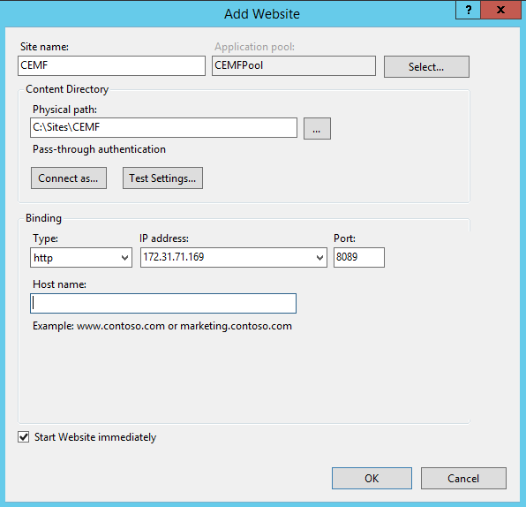

* 1. To open the site you can click the Browse link at the right side of the IIS Manger.
     + Or you can open the link in the browser by typing http://<IP>:<Port>/index.html

At this point the site will not run correctly since we need to modify the files and copy dependencies to local folder that way the website will work event without internet connection.

## Modifying Files to Run the Site without Internet Dependencies

1. Open explorer and navigate to the website folder (C:\Sites\CEMF).
2. Unizp *patch-local-run.zip*. This zip file will be provided to you by CEMF team.
   1. Once extracted, copy the *static* folder and overwrite the *static* folder in your website folder.

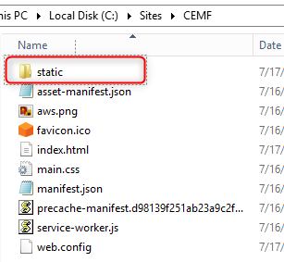

* 1. After overwriting the website static folder, it should contain the following new folders. These folders contains the site dependencies that we move locally.
     1. bootstrap folder
     2. jquery folder
     3. webfonts folder
  2. It also contains new files:
     1. js\popper.min.js
     2. js\workbox-sw.js
     3. css\all.css

1. Open \*index.html* and modify the links highlighted in red with the equivalent links highlighted in green below. Then save the file.

|  |
| --- |
|  |
| Replace above links with the links highlighted with green below. |

|  |  |
| --- | --- |
| Old | Change to |
| https://stackpath.bootstrapcdn.com/bootstrap/4.1.3/css/bootstrap.min.css | /static/bootstrap/bootstrap.min.css |
| https://use.fontawesome.com/releases/v5.5.0/css/all.css | /static/css/all.css |
| https://code.jquery.com/jquery-3.3.1.slim.min.js | /static/jquery/jquery-3.3.1.slim.min.js |
| https://cdnjs.cloudflare.com/ajax/libs/popper.js/1.14.3/umd/popper.min.js | /static/js/popper.min.js |
| https://stackpath.bootstrapcdn.com/bootstrap/4.1.3/js/bootstrap.min.js | /static/bootstrap/bootstrap.min.js |
|  |  |

1. Open *\\service-worker.js* modify the link in red with the one in green. Then save.

|  |
| --- |
|  |
| Edit link above with the link highlighted in green. |

|  |  |
| --- | --- |
| Old | Change to |
| https://storage.googleapis.com/workbox-cdn/releases/3.6.2/workbox-sw.js | /static/js/workbox-sw.js |
|  |  |

1. Save the files then do a hard refresh (CTRL+F5). After refreshing, you should see the CEMF login page.

Proceed login and navigate through the site.

# How to Re-build CEMF Frontend

You need to rebuild front-end if CEMF solution template failed to deploy the front-end in designated S3 bucket static hosting due to lack of internet connectivity. When you run the CEMF CloudFormation template it downloads the front-end artifacts from the public source that requires internet connection, if this fails it will leave your front-end S3 bucket empty but it will not cause the CloudFormation to fail.

Follow these steps to build the front-end.

1. Download Node js. You need this to build the front-end.
2. Download the frontend code from either of the following sources:
   1. <https://awsmigrationfactory.s3.amazonaws.com/frontend-code/v1.3.zip>
   2. Or official GIT repository <https://github.com/awslabs/aws-cloudendure-migration-factory-solution/tree/master/source/frontend>
3. Update the *src/config.js* file with the correct *region* where you want to deploy the front-end, API URLs, Cognito User pool Id, and Coginto App Client Id.
   1. You can find these API URLs in CloudFormation stack Output tab.

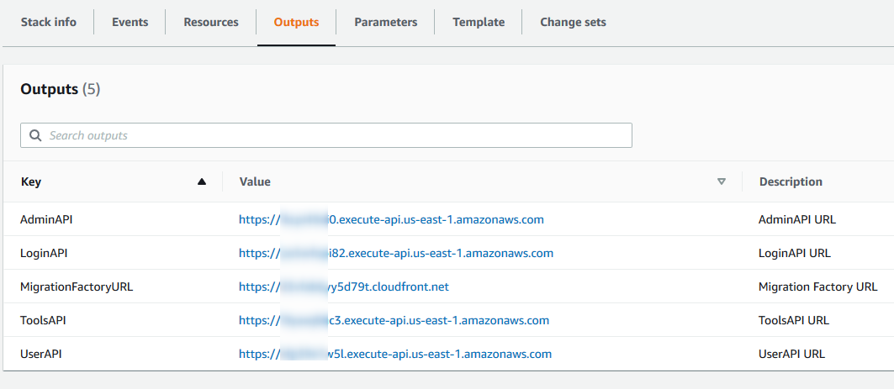

* 1. You can find the *pool id* in your Cognito CEMF User Pools under General settings.

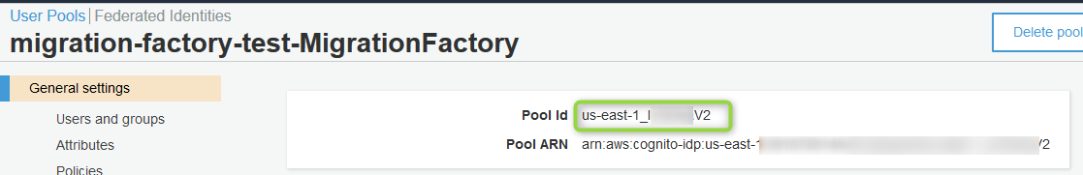

* 1. You can find the *App Client ID* in *General Settings -> App Clients* under Cognito User Pool.

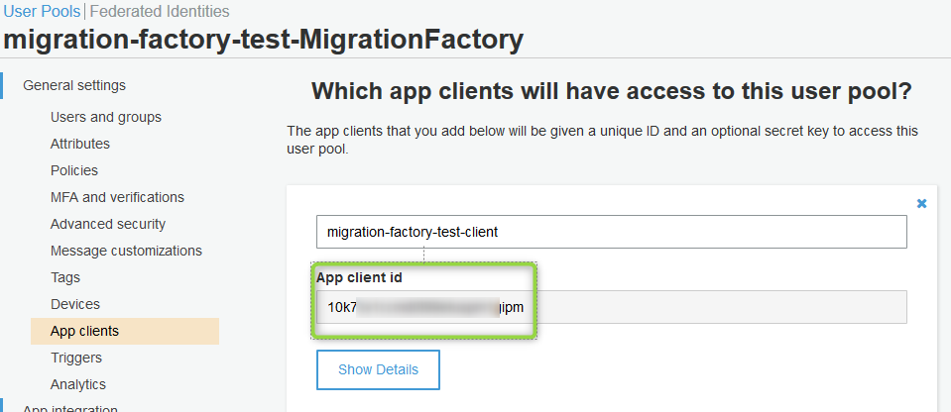

1. Run the following commands in the root frontend folder where you see the *package.json*. Ignore the warning when you run build.

npm install

npm run build

1. You should see a folder "*build*" after running npm commands. The content of the build folder contains the frontend artifacts that will be deployed to hosting server – S3 or web server.

# Hosting the Frontend in CEMF S3 Bucket

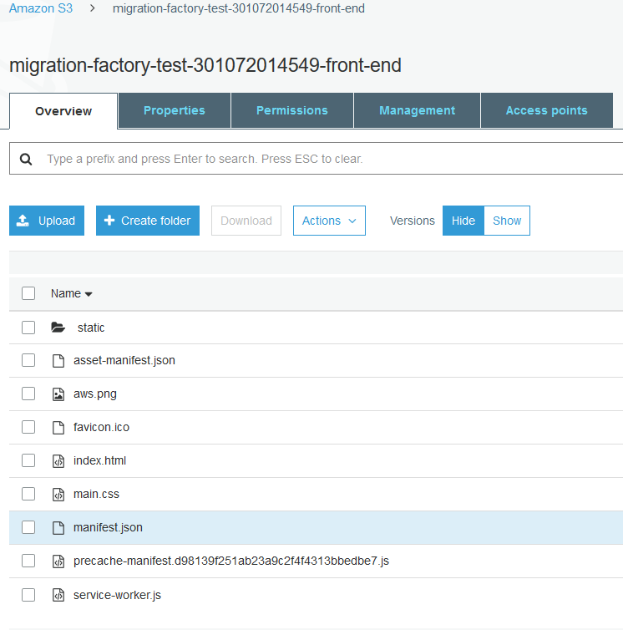After successful rebuild follow this steps to deploy the frontend build in CEMF S3 bucket.

For Steps how to rebuild go to How to Re-build CEMF Frontend

1. Copy all of the contents of the front-end scripts. If you rebuild the front-end you can find the front-end content in *build* folder.
2. Upload it all the content in CEMF S3 front-end bucket. Make sure
   1. The bucket is not encrypted
   2. If the solution was deployed to any region other than us-east-1, wait for 2 hours for cloud-front to populate

The CEMF fron-end bucket is automatically created by CEMF solution template and usually have this bucket name format: *migration-factory-YYYY-XXXXXXXXXXXXX-front-end*.